North Korea, a security and diplomatic analysis of a regional and global threat to the stability for world peace”

Master’s Thesis by

Matar Mubarak Al-Hemeiri

Paris Sorbonne Abu-Dhabi Université

Superviser: Jean-Vincent Holeindre

Professor at the University Paris II Panthéon- Law and Social Sciences department

Table of Contents
Summary:……………………………………………………………………..5
1- Introduction:……………………………………………………………………..6
Significance of the study:……………………………………………………………………..8
2- The Korean War and Armistice Agreement……………………………………………………………………..11
2-1- History of the Korean Peninsula……………………………………………………………………..11
2-1-1- Japanese intervention in Korea 1876……………………………………………………………………..12
2-1-2- US intervention in Korea 1882……………………………………………………………………..13
2-1-3- Chinese-Japanese Competition regarding Korea until 1895……………………………………………………………………..14
2-1-4- The Russian-Japanese rivalry over Korea until 1910……………………………………………………………………..16
2-1-5- The growth of the Korean national movement and the emergence of Kim Il Sung……………………………………………………………………..18
2-1-6- Korea in World War II 1939-1945……………………………………………………………………..19
2-1-7- US-Russian understanding on dividing Korea into two states……………………………………………………………………..20
2-2- The Korean War 1950-1953……………………………………………………………………..22
2-2-1- Causes of the War……………………………………………………………………..23
2-2-2- Results of the War……………………………………………………………………..23
2-3- Korean Armistice Agreement……………………………………………………………………..24
2-3-1- Background and scope……………………………………………………………………..24
2-3-2- Armistice Agreement Laws……………………………………………………………………..26
2-4- Inter-Korean Relations from a Historical Perspective……………………………………………………………………..26
2-4-1- The policy of existential rivalry, 1948-1972……………………………………………………………………..28
2-4-2- Cautious Coexistence, 1972-1992……………………………………………………………………..29
2-4-3- Nuclear and Economic Crisis……………………………………………………………………..29
2-4-4- Relationships between Korean countries and the US……………………………………………………………………..30
2-4-5- Inter-Korean Relations towards the Future……………………………………………………………………..30
2-4-6 North Korea's military and nuclear capabilities……………………………………………………………………..30
2-4-7-The constitution and the political regime of North Korea……………………………………………………………………..33
3-International human law……………………………………………………………………..38
3-1- Achieving a balance between humanitarian and military necessities……………………………………………………………………..41
3-2- Discrimination, Proportionality and Reserves……………………………………………………………………..41
3-3- Restrictions and Prohibitions regarding Certain Methods and Means of Combat. ……………………………………………………………………..42
3-3-1- Prohibitions and general restrictions……………………………………………………………………..42
The principles of IHL prevent any use of weapons that results in serious damage and unnecessary injuries to the lives of civilians and their property. In addition, these principles prohibit the intimidation of civilians and require the distinction between them and military members when using weapons in military actions……………………………………………………………………..42
3-3-2- Special prohibitions……………………………………………………………………..42
4- Application of International Humanitarian Law to ongoing North Korean violations……………………………………………………………………..43
4-1- Existing treaties and conventions……………………………………………………………………..43
4-1-1- Geneva Conventions and Protocol (I)……………………………………………………………………..43
4-1-2- Illegal Weapon……………………………………………………………………..44
4-2- How can we prevent violations of IHL……………………………………………………………………..45
4-3- How to punish perpetrators of violations of IHL ……………………………………………………………………..45
4-3-2- National Prosecution……………………………………………………………………..46
4-3-3- Universal jurisdiction……………………………………………………………………..46
4-3-4- International criminal tribunals……………………………………………………………………..47
4-5- Customary IHL……………………………………………………………………..48
4-6- When does International Humanitarian Law apply?……………………………………………………………………..49
4-7- Treaties Safe Guarding Victims of Armed Wars……………………………………………………………………..49
4-7-2 Treaties regarding the Protection of Cultural Property and the Environment……………………………………………………………………..59
4-8-Security council sanctions on the North Korean regime……………………………………………………………………..52
4-8-1 The US sanctions……………………………………………………………………..53
4-8-2 Other countries sanctions……………………………………………………………………..53
4-9- Scope of IHL ……………………………………………………………………..
4-9-1- Wounded, sick and drowned personnel……………………………………………………………………..54
4-9-2- Persons detained or arrested on the basis of their association with an Armed Conflict party……………………………………………………………………..55
4-9-3- Prisoners of war (POW) in International Armed Conflicts……………………………………………………………………..55
4-9-4- Civilian Detainees in International Armed Conflicts……………………………………………………………………..56
4-9-5- Fundamental safeguards for any person affected by armed conflict……………………………………………………………………..56
5- Rules applicable in armed conflict……………………………………………………………………..57
6- Conclusion ……………………………………………………………………..
7- References……………………………………………………………………..62
Questionnaire……………………………………………………………………..68
Annexes:………………………………………………………………….70

Summary:

Since the beginning, North Korea has never ceased its wrongdoings and crossed its outskirts on its neighbors , bolstered the atomic task with the absence of regard and infringement of human rights law. Numerous investigators said that Pyongyang is a mobilized system sorted out around an almighty head. The geological position of North Korea credits to its long haul wars. So after the presentation the initial segment (2) quotes the historical backdrop of Korean War and peace negotiation understanding. To be sure, a ton of reports demonstrate that this nation is damaging the universal human rights law by confinement’s camps the section (3) will be about the International human law. The world feels compromised by the North Korea's improvement of its atomic weapons and ballistic rockets. The last section (4) clarifies the use of worldwide philanthropic law to continuous North Korean infringement.

- Introduction:

An UN analytical group has affirmed the genuine infringement of the human rights framework submitted by the North Korean government against previous and current political rival and individuals jailed in the detainment camps, saying they have endured "unspeakable appetite and misuse". The detainment camp known as Yodok and there is likewise in excess of 9 confinements camps in this nation and the detainees in those camps are somewhere in the range of 150,000 and 200,000 they are compelled to fill in as a slave . (See Annexe 1). A few people progressed toward becoming observer after they were tormented and endured in those detainments camps one of them was the staff guardian (Lee-youthful kik ,1987-1989) of Kim Jung-Il who was captured from china since he was scrutinized the system and furthermore Kim tae-jin (in Yodok 1988–1992) when he had 18 years of age he was captured in light of the fact that he wrongfully left North Korea, and a writer from South Korea who composed a book about the warble camp Kang chol hwan "TheAquariums of Pyongyang" concerning the time he spent in their tents. The Northern system damaged the human rights by kidnaping and capturing, coaching individuals in a detainment camps.

Additionally, United Nations Works force under helpful rights said on September seventeenth, 2013 that overcomers of a North Korean camp had endured "unspeakable yearning and misuse" and that was a proof of boundless and methodical maltreatment by the state. Michael Kirby, leader of the autonomous examination, said the declaration of those ousted by North Korean, incorporating previous political detainees in jail camps, made during hearings session in Seoul and Tokyo a month ago uncovered precise harsh conduct by Pyongyang. He expressed that: "Korea activities speak to expansive examples that can comprise deliberate and offensive infringement of human rights", he kept saying that "the autonomous examination would try to recognize North Korean organizations and authorities who submitted these maltreatment".

The Human Rights Council, situated in Geneva, was entrusted with exploring the North Korean maltreatment, including potential violations against mankind. Then again, North Korean representative Kim Yong-ho said that "the examination was false and expected to ruin Pyongyang's notoriety so as to weight it to change the system in North Korea", including that "the EU and Japan have added a political character to the report in partnership with threatening US arrangement".

Implications of the study:

UN authorities cautioned that ongoing understandings that included the United States of America, South and North Korea concerning the Korean Peninsula, did not improve the present circumstance in the Northern piece of Korea that worries the helpful privileges of the individuals.

UN focused on the significance of tending to the compassionate circumstance of the individuals of North Korea and encouraged an answer for its rehashed infringement. "The human rights circumstance right now has not changed on the ground," said Tomas Ojea Quintana, a United Nation agent on helpful rights in North Korea.

Pyongyang remains denounced by numerous universal association including the UN and the worldwide bar association (IBA) of damaging human rights against its kin. A United Nations commission finished up in 2014 that North Korea are proceeding to carry out wrongdoings a gainst mankind and the IBA reports results declarations detainees previous and gatekeepers and they said that somewhere in the range of 1,500 and 2,000 detainees were tormented additionally a large portion of them are Child.

"Actually, regardless of all the worldwide improvements on the planet a year ago, it is miserable to perceive how the standard human rights are not changed, making the circumstance perilous" said Tomas Ojea Quintana to columnists in Seoul.

He kept saying: "A large portion of the populace endures hardship in the social and financial matters right field that include: instruction, work, wellbeing, lodging, water, nourishment, general wellbeing and standardized savings.

North Korea denies human rights allegations, guaranteeing that the worldwide network is utilizing these allegations as a political stunt to seclude North Korea. North Korea encouraged the Security Council group of the United Nations to deny the US exertion to hold a gathering to talk about Pyongyang's human rights record, saying that this move would turn around ongoing harmony advancements.

On the off chance that the gathering is held, it will be the fifth time the board holds its yearly gathering to talk about the impacts of North Korea's infringement of human rights on the universal harmony and security.

Consistently since 2014, the United States has gotten the fundamental nine decisions on holding the gathering however it is constantly experienced by resistance from China. Consistently China requests a procedural vote to anticipate holding the gathering as human rights related issues must be examined in Geneva-based Human Rights Council as opposed to in the Security Council.

A report by a worldwide commission of request in 2014 affirmed gigantic infringement of philanthropic rights in the northern piece of Korea and discovered systems of confinement camps where prisoners are tormented, starved and extra judicially executed. The report likewise blamed Kim Jong-un for perpetrating genuine wrongdoings against mankind and said that he could be pursued for them. In any case, this report was dismissed by the North Korean specialists asserting that this report contains manufactured actualities dependent on the declaration of dissenters who deceived their nation.

The discussion over human rights infringement in North Korea comes when both China and Russia are attempting to make the Security Council stop the authorizations made against Pyongyang to improve atomic demobilization.

From the abovementioned, it is proof that examining North Korea's infringement against human rights is a critical issue that must be managed right away.

Moreover, North Korea is known additionally in disregarding likewise the worldwide law by manufacturing a great deal of things like for instance:- Foreign monetary forms, pharmaceuticals and cigarettes.

David Asher, an investigator said : '"North Korea has turned into a "soprano express" a legislature guided by an authority whose activities ,mentality , and affiliations progressively take after those of a sorted out wrongdoing family in excess of an ordinary country . And furthermore David affirms that, North Korea is the main nation which accepts wrongdoing as a piece of it's national financial procedure and international strategy .

Joe Chan Yung, was surrendered in 2010 from North Korea who was selling outside products in the North Korean underground market he said that the motivation behind why the North Koreans local people works in market is just the sustenance, including that the UN office after the meetings with 214 turncoat, the administration didn't put and control laws to verify their day by day life needs. Additionally, the UN human rights official Daniel Colling said that "the absence of business movement is a demonstrate that the individuals face a danger of detainment, the cooperation in business market is to make a trip all around and it's restricted by the nation" .

After the rehashed occurrences that unmistakably show North Korea's antagonistic and oppressive frame of mind towards its residents and the individuals of its neighboring nations, particularly South Korea. We thought that it was important to address this issue and lead an uncommon report about it. The principle issue of this examination is the means by which we can clarify the distinguishing proof of North Korean infringement and what's the formation of a legitimate system that can be utilized to arraign North Korean pioneers under International Humanitarian Law.

2- The Korean War and Armistice Agreement

2-1- History of the Korean Peninsula

North Korea is had a spot in the East of Asia and it's domain's space proportional to 47,000 mile square with a 23,79000 million populace and it has 9 regions and 4 regions, the most realized regions are: Pyongyang which is the capital and Chongjin, Hamhung and Kaesong.The Korean individuals originated from the North of chine yet the Chinese "Han"family settled quick the Korean kingdom "Eman" in the 194B.C. until the fourth century's. The main Korean nation was made by Kim family in the seventh century under the name of "Koo Choo sun".North Korea had a great deal of issues and pressures with japan, for instance, japan colonized Korea In 1352 and 1592. In 1876 they marked two settlements among USA and France for exchange debate perceive Korea as a free nation and that was a reason of a war among japan and chine in 1894 until 1895 and between Japan versus Russia in 1904-1905, Japan won the two wars. In the 1910 japan included Korea as a bit of their nation and region until 1919. In the 1945 the Korean landmass reported their freedom and in 1948 North Korea and South Korea were isolated .

North Korea by the individuals' gathering they casted a ballot Kim Il Sung as the Marshal

of the nation. The most significant thing that in December 1945, the United States and the Soviets consented to run the nation in what was portrayed by the Joint US-Soviet Commission as the result of the Moscow Meeting of Foreign Ministers. With four years of self-sufficiency under global tutelage.

The Korean Peninsula was a piece of the Japanese Empire, which involved it from 1920 until World War II, when the Soviet Union, in concurrence with the US, proclaimed war on Japan. The Soviet Union prevailing with regards to consummation Japan's control of Korea up to the 38th Latitude, which spoke to North Korea's present fringe with South Korea after the affirmation of the two states. Japan additionally gave up south of this line to US powers. In 1945, the US arrived at a concurrence with Russia to separate the Korean Peninsula, along the 38th Latitude, where the Soviets involved the region north of this line (North Korea), and the Americans involved the southern area. In 1948, two North and South Korean states were shaped, socialist controlled North Korea was lance headed by Kim Il Sung and US-controlled South Korea was driven by Syngman Rhee. (See add 2)

2-1-1- Japanese intervention in Korea 1876.

In spite of Korea's reliance on China, it kept up close relations with Japan. Generally, Korea sent individuals from political missions on authority events to offer blessings to the Emperor of Japan.

In 1860 and 1862, Korea treated two Japanese exchange missions gravely, which required the dispatch of a disciplinary undertaking to Korea. Notwithstanding, the Japanese ruler did not tune in to this counsel.

In 1875 the Japanese government restored its solicitation to the Korean government to open its ports for Japanese exchange, during which the Japanese military powers directed a Military Parade off the eastern and western shore of the Korean Peninsula, and opened flame and shelled the Korean ports. Japan expected through this move to intrigue the Koreans so as to open the entryway for arrangements with Japan.

Japan at that point stopped the correct chance to build up conciliatory relations with Korea, and had the option to close an arrangement on February 26th 1876 known as the Convention of Ganghwa which included: The acknowledgment of Koreas as an autonomous state and Opening three Korean ports to Japanese exchange, Granting Japan admission to set up departments in Korea, Giving Japan extra benefits, including the arraignment of Japanese residents over Korean domain as indicated by Japanese laws. Accordingly, the formal ties among Korea and China finished after this settlement and Japan increased a political and financial decent footing in Korea. It appears that the reasons why Japan demanded building up conciliatory relations with Korea come back to four primary reasons which are:

1.Increasing Japanese-Chinese challenge in Korea, which was liable to Chinese sway until a center eighteenth century and Increased outside impact in the Far East through exchange and minister missions that had political points, which raised Japan's worries and pushed it to contend over Korea.

2.The Japanese living conditions, as they were presented to a populace blast and to dispose of this issue Japan tried to get crude materials for the business and to open markets for its items in Korea.

3.The significance of Korea's key area as Japan's fundamental door to East Asia.

2-1-2-US mediation in Korea 1882.

In spite of the separation strategy declared by Korea against Western nations, numerous nations attempted to enter this segregation somehow, including sending evangelists to spread Christianity, regardless of whether through China to Korea, in the wake of having the option to break its disengagement or send it legitimately to Korea. The patriot movement of Christians against Confucianism in Korea prompted their mistreatment in 1839, however Western nations kept on sending a preacher campaign.

In 1866, Christians in Korea were exposed to another slaughter, which provoked Western nations to demand breaking Korea's segregation. After the Christians slaughter in 1866, US business send (General Sherman) headed towards one of Korea's waterways and it was decimated by the Koreans. In 1867, two US travels neglected to discover what precisely what happened to (General Sherman) dispatch. From that point forward, what the United States sent a bigger crusade in 1867, to build up discretionary relations with Korea, which prompted an equipped clash finished with the retreat of the Americans after they devastated Korea's beach front big guns.

In the wake of marking the Convention of Ganghwa among Japan and Korea in 1876, which urged the United States to restore its enthusiasm for Korea, which was pushed by China to hold comparative arrangements with the Western nations so Japan won't be the main nation having relations with Korea. Thus the United States Department of Naval Affairs sent the maritime naval commander (Robert W. Schofield) to sign an exchange arrangement with Korea, and with the help of Chinese ambassadors, the US marked the main US-Korean settlement in 1882, which required the exchange of consular and conciliatory delegates between the two nations, it additionally incorporated that "if other worldwide forces managed any of the two governments, the other state must report this case so as to arrive at a serene understanding".

State that Korea government constrained the United States Government towards the presentation of a proviso in the bargain content expressing that "Korea's subjection to China keeps on being dynamic" however the US rejected it.

Other European nations dashed to sign comparable settlements with Korea based on the US-Korean arrangement. These bargains incorporates: British-Korean arrangements of 1883, German-Korean in 1884, Italian-Korean in 1884, Russian-Korean in 1884, and French-Korean in 1886

2-1-3- Chinese-Japanese Competition regarding Korea until 1895.

The establishments of this test stretch out way back to late sixteenth century, when Japan assaulted Korea during the standard of (Toyotomi Hideyoshi) in the years 1590 and 1592 and 1597, as an underlying advance to assault China. Regardless, China's forces repelled Japanese forces to draw once more from these attacks in 1598, and starting now and into the foreseeable future Korea's kept subordinate to China.

Denoting the Convention of Ganghwa with Japan was one explanation behind the two countries' restriction over Korea, which provoked the split of the choice drifts in Korea into two wings. The principal addressed by the Korean court was dedicated to China, while the other wing addressed by various forces was devoted to Japan.

In any case, the crowds that broke out in Korea in 1882 came to fruition for both China and Japan concessions from Korea to situating troops in the Korean capital (Seoul), trailed by a type of cognizance among China and Japan over Korea realized a the deal of (Tientsin) in 1885 which stipulates to:

1. The Withdraw of the forces of the two social events from Korea.

2. Neither gathering has the choice to send troops to Korea beside with the consent of the two countries.

This suggests the deal apparent parity among China and Japan over Korea, yet the following years conveyed things to an accident between the two countries over Korea through two events:

1. Killing (Kim Ok-gyun) because of Chinese expert assassins and their Korean's complicit in Shanghai at the year 1894.

2. Sending Chinese troops to cover the Donghak Peasant Revolution, which was an insubordination to the Korean government and against the proximity of outcasts in the country.

Under the Treaty of Tientsin, both China and Japan sent their forces to Korea. After the situation was offset, China would not draw back its forces until the withdrawal of the Japanese troops from Korea, so the various sides went into trades which failed and incited a war between the two countries, in August 1894 during which Japan achieved triumph over China, having included a couple of essential domains until they came to past the Yellow River and headed towards the Great Wall of China.

Dealings between the two social affairs was proceeded until they touched base at the Treaty of Shimonoseki (see include 3) in April 17th1895 which included:

1. Chinese affirmation of the self-sufficiency of Korea.

2. Chinese concession of Pescadores and Formosa Islands and Liaodong Peninsula, including Port Arthur.

3. China is fined with 200 million taels of silver to Japan.

4. Opening five vital ports in China to Japanese trade.

5. Granting Japan the advantage of Most Favored Nation (MFN).

2-1-4- The Russian-Japanese rivalry over Korea until 1910.

Japan's concessions from China raised the worries of certain nations, particularly Russia, which had exchange ties with Korea and the Far East to arrive at warm waters.

Along these lines, Russia, Germany and France issued final proposal to Japan in April 1895, mentioned the deserting of Japan on Liaodong Peninsula. Japan had to react to these requests in return for monetary remuneration equivalents to 300 million taels paid by China to Japan.

Russia started building up itself in the area, and rushed to close the Li–Lobanov arrangement in 1896 with China, which filled in as a military collusion among Russia and China against Japan.

In light of the bargain, Japan sent its agent Yamagata to Russia to arrive at a comprehension of their interests in Korea. Japan recommended to separate Korea into two sections at the 38th scope, a northern part constrained by Russia and a southern part constrained by Japan, yet the Russians dismissed this proposition as they planned to have full power over the Korean promontory on the long haul, particularly the southern rural territories [ ].

In June 1896 the two nations consented to the Yamagata–Lobanov Arrangement, which affirmed:

1. The two nations will bolster the Korean lord's endeavors to reestablish security and request in Korea by giving sufficient advances with the goal that Korea can fabricate powers to keep up security and request to give essential assurance.

2. The production of the Japanese transmit lines in South Korea, with Russia holds the benefit of structure its broadcast lines in Seoul to the Russian outskirt.

3. The understanding incorporated a mystery statement stipulating that on the off chance that it ended up important to send troops to Korea, the two nations would counsel on setting up an unbiased zone between their two territories of impact in Korea.

Be that as it may, Russia overlooked the Yamagata–Lobanov Agreement and acquired new concessions for logging and mining in Korea. Russian specialists started preparing the Korean armed force, grounding the Japanese-prepared military, expanding Russia's supervision over Korea's funds. As Russia had interests in Manchuria, Japan offered Russia a responsibility of not asserting impact regions in Manchuria consequently of Russia's affirmation lifting its hand from Korea. As a result the Nishi–Rosen Agreement was marked in April 1898, which expressed:

1. Both nations must perceive the freedom of Korea.

2. Refrain from helping the Korean armed force or redesign Korea's funds.

3. Russia's acknowledgment of Japan's business and modern interests in Korea.

Russia did not maintain its responsibilities with Japan. The last consulted with Russia in 1903. While the dealings were in progress, the Russian Cesar sent immense powers eastbound through the Siberian railroad lines. Japan cut off dealings and proclaimed war on Russia in 1904 which prompted the Treaty of Portsmouth in September 1905, which stipulates:

1. Japan's procurement of Port Arthur.

2. Japan got the concession of angling in Siberian waters.

3. Russia's acknowledgment of Korea's addition to Japan.

4. Japan's control of development extends in Manchuria.

During the Russian-Japanese war 1904-1905, Japan had the option to consent to an arrangement with Korea in 1904 which transformed Korea into Japanese protectorate, and permitted to meddle in Korea's inside issues. In 1905 Japan was conceded full command over the Korean Foreign Relations.

After the war Japan and Russia held four understandings, incorporating a mystery bargain in July 1907, which stipulated "acknowledgment of the political relations of solidarity among Korea and Japan, in return for Japan's acknowledgment of Russia's unique advantages in Mongolia".

To affirm Japan's power over Korea, it consented to an arrangement with Russia, wherein Russia perceived Japan's privilege in political supervision over Korea in return for thinking about Russia as the Most Favored Nation (MFN) in Korea. In January 29th, 1910 Japan declared the official extension of Korea, supplanting the name of the capital Seoul to progress toward becoming Keijo.

2-1-5- The growth of the Korean national movement and the emergence of Kim Il Sung:
Korea stayed under Japan's influence from 1910 until the part of the bargain World War of 1945. During this period, the Korean national development started to rise, solidified in the figure of Kim Il Sung, (see add 4) who was engaged with the counter Japanese progressive battle and shaped the Korean Communist Youth League in 1927. He established the Korean People's Army (KPA), the progressive military of the individuals in 1932, and established the Korean National Association, which was the principal administrative body of the Unified National Front against Japan in Korea. He was chosen its leader and drove the furnished battle until the part of the arrangement in 1945.

2-1-6-Korea in World War II 1939-1945:

During the most recent long periods of war, a few global held gatherings to determine issues that pursued the war, and the three meetings identified with Korea were:

1. Cairo Conference in December 1943: US President Roosevelt met the British Prime Minister Churchill and the General Chiang Kai-shek pioneer of The National Government of China, in the Egyptian capital Cairo, and toward the part of the bargain they communicated the Cairo Declaration, which incorporated a passage about Korea expressing that "Korea is a free and autonomous nation".

2. Yalta Conference in February 1945: in which the members focused on the need to perceive Korea's autonomy and the departure of every Japanese troop. This meeting clarified precisely that Russians ought to involve the Northern side of the nation and the US ought to possess the Southern side.

3. The Conference of Potsdam, July 1945: Parties that took an interest in the gathering were the Soviet Union, China, Britain just as America. The meeting underscored the need to make an autonomous state in Korea. The representatives likewise talked about the issue of deciding the line that the US Army ought to guarantee the demilitarization of Japanese troops working south of it, while the Red Army (Soviet) deal with incapacitating Japanese powers working north of the line. During the gathering General Mathias Gardner proposed utilizing the 38th Latitude to isolate Korea into two sections, and his proposition was endorsed, thus the nation was separated by the 38th scope. In this manner the duty of North Korea was on the Soviet Union's shoulders, while South Korea's obligation was on the United States' shoulders.

4. Moscow Conference 1945: After the endorsement of Stalin's concept of the edicts o n Korea by the Secretary of State of America (Hopkins) in May 1945, the Soviet Union, Britain, China just as the United States held a meeting in Moscow to talk about the status of Korea completely under worldwide trusteeship framework, likewise a joint board (US-Soviet) was shaped to contact the Korean Social and Democratic gatherings and bodies so as to shape between time government in Korea which exercise its forces under the four nations' trusteeship framework for a period five years.

2-1-7-US-Russian comprehension on partitioning Korea into two states.

The Moscow gathering in December 1945 brought about the arrangement of a joint council (US-Soviet) regarding the equitable gatherings and social associations so as to give the important help to verify political, monetary and social advancement and accomplish the national freedom of Korea through the development of a between time government in Korea for a long time.

Moscow gathering's choices prompted the flare-up of challenges in Korea to express the discontent over trusteeship standard. The dissented gatherings mentioned an immediate and full freedom of Korea. During these dissents a sort of distinction in perspectives happened between the Soviet Union and the United States, as the Soviet Union requested that the Joint Commission counsel the substance parties just about the choices of Moscow's meeting, while the United States requested that the Joint Committee counsels all gatherings that don't challenge crafted by the Joint Commission. Furthermore a distinction in point see between the two nations happened on the way toward holding decisions in Korea to shape the break government. Washington's view was that general decisions ought to be held for impermanent congregations of the North and the South, in this manner adding to the arrangement of the between time government in all of Korea. While Moscow saw the need to choose a Constituent Assembly for the all of Korea, comprising just of the fair parties for the choices of the Moscow's Conference with a similar number of delegates for the North and the South.
Looked with this variety in various perspectives, the US government proposed to allude the case to the United Nations body in August 1947, which chose shaping a between time advisory group of the United Nations in Korea, speaking to China, Australia, India, Philippines, France, San Salvador and Syria, and characterized the assignments of the Commission as pursues: Holding general decisions in Korea and quicken the arrangement of a national government in Korea, quicken the departure of the occupation powers from Korea.
Be that as it may, the Committee had the option to do its work just in South Korea, on account of the resistance of the Soviet Union, and the two nations neglected to arrive at a satisfactory equation for foundation bound together government administering all of Korea, which came about to the development of two governments: one in the Southern piece of Korea driven by Syngman Rhee and its capital is Seoul in May 1948, and the other in North Korea driven by Kim Il Su ng and its capital is Pyongyang in September 1948. The Socialist camp and the Soviet Union scrambled to perceive the North Korean state, while the US and its partners perceived the South Korean state. Thus, the Soviet troops and the US powers broke their ties with South Korea in 1948 and 1949 separately.

Along these lines, there were two Korean governments. The Southern and Northern each bolstered by the United States of America and The Soviet Union separately. Korea turned out to be a piece of the Cold War and a performance center of ill will and strife between Western entrepreneur and communist after war camps during the post-World War II.
2-2-1950-1953 Korean War:
The war in Korea broke out for two reasons. To begin with, the political reason spoken to by the choice to separate Korea as indicated by the choices of the gathering in Potsdam 1945. The subsequent reason is the financial factor as the world powers consented to separated the nation into two sections: the northern part which is occupied by 9,000,000 individuals what's more, the fundamental wellspring of power and substantial enterprises are found, and the southern part with a populace of twenty-one million individuals depending on farming and lacking of businesses and vitality sources. Accordingly, the financial stagnation started to think about itself every one of the exercises of political and public activity, and the immediate reason for the war is the event of conflicts between the two powers of the legislatures from the year 1949. In June 1950, riots arrived at a pinnacle when Kim Il Sung drove his North Korean troop over the fringe towards south so as to accomplish Korean solidarity. Then again, the leader of South Korea, Syngman Rhee, raised the trademark "Creeping towards the North", to reunify nation by power, and mentioned military help from the American president.
With the weakening of the circumstance in Korea and the development of the northern powers toward the south, the issue relating war was accounted for to the United Nation by the United States of America, and in June 1950 the Security Council issued a goals that: Denounce the equipped assault by North Korea and require a discontinuance of war with withdrawal of the Korean armed forces past the outskirts.

At January 1951 a gathering of four nations: United States, Britain, China and Soviet Union was held to settle political issues in Far East, and in spite of the slowed down dealings between gatherings included, the consented to the accompanying arrangements:
1. June 1953: it was consented to put detainees who will not return home under the supervision of a five-country council led by the Republic of India.
2. July 1953: building up a peaceful area (2 km) on each side of the visitors.
The Korean War finished following three years, yet it didn't join the nation. There is a division of the nation into the North and South. The Soviet Union backings the North while the United States is a partner toward the South. During 1954 a universal gathering was held to talk about the issue of Korean solidarity, yet it neglected to accomplish solidarity between the two nations.
2-2-1-Causes of the War:
Both Sung and Rhee proclaimed that they spoke to the authenticity of the Korean Peninsula and that one day they would be triumphant. North Korea's military was progressively taught, prepared and prepared than the dreaded and harried South armed force, which urged Pyongyang to touch off the war.

In June 1950, the main Cold War military move made spot, when somewhere in the range of 75,000 North Korean troops crossed the 38th scope, crossing their outskirt with South Korea, attempting to involve and control the whole promontory, acquiring help from the Soviet Union.
In the disturbance of Seoul's military and its officers escaping the showdown, the United States, together with some UN part states, mediated in the war as a "war against worldwide communist powers" and "an image of East-West clash, great and abhorrence."
2-2-2-Results of the War:
More than 5,000,000 lives were lost, the majority of them regular citizens of the two Koreas, including somewhere in the range of 40,000 US military staff, and in excess of 100,000 US troops have been injured. The warring gatherings marked a détente in July 1953 that enabled North Korean and Chinese detainees to return home, and South Korea conceded 1,500 square miles of extra land close to the 38th scope.
2-3-Korean Armistice Agreement
2-3-1-Background and extension
The Korean Armistice Agreement is a ceasefire marked on 27 July 1953 between North Korea, China and the United States on the North Korean side of the previous neutral territory (DMZ) which finished the between Korean War. Albeit South Korea did not sign, the different sides are still in clashing terms mentally when a harmony contract has not been approved. In 1954, Chinese Prime Minister proposed the execution of a harmony arrangement on the Korean Peninsula. In any case, this proposition did not get the required consideration, and no harmony has been accomplished. The marking of the neutral territory (DMZ) and characterizing new fringes between the two nations, prompted ceasing military activities.
The neutral territory is close to the 38th scope and has been cut off among North and South Korea since consenting to the Armistice Arrangement in 1953.
DPRK does not consent to the Armistice Agreement, subterranean insect more as it considers it invalid. Even when there is an article forbidding this demonstration, as the Article V (passage 62) states: "The Articles and Paragraphs of this Armistice Agreement will stay as a result until explicitly supplanted either by commonly adequate revisions and augmentations or by arrangement in a proper understanding for a serene settlement at a political level between the two sides."
The arrangements of the understanding is relevant to all land, ocean and aviation based armed forces of the two sides consequently they should comply with the peaceful area (DMZ) conditions. Moreover, the pioneers of the two clashing gatherings must, inside their separate commands, set up every single vital technique to guarantee full obeying of all arrangements of the Armistice.
In any case, as is apparent from numerous models, North Korea has not conformed to the Armistice Agreement. Though Article 1 of the Armistice expressly expresses that "any gathering is disallowed from submitting any antagonistic demonstrations in the neutral ground", it additionally forbids entering the peaceful area without the assent of the Military Armistice Commission".
Article (2) gives that all threats must be suspended totally following a 12 hours time frame which starts promptly from the marking of the Armistice, what's more the article expressed that no special cases are acknowledged in regards to the neutral ground.
Notwithstanding the abovementioned, North Korea's infringement of the Armistice Agreement are delineated by its inability to conform to Article (4), which accommodates the holding of a political meeting in the period that pursued the consenting to of the cease-fire arrangement, through which the issue of departure of every single outside trooper from Korea and the exchange of a serene settlement of the Korean issue.

2-3-2- Armistice Agreement Laws
Most researchers saw Korean cease-fire as transitory harmony apparatus as it does not part of the arrangement Korean war. Be that as it may, the plausibility of applying the laws of this Agreement under IHL principles to indict North Korea and consider it responsible for rehashed infringement were examined by numerous researchers.
Through survey the Agreement, its laws can be come back to set of understandings and past laws chiefly The Hague Conventions and The Laws of Land Warfare [ ]. One proof is Article 36 of The Hague Convention, which states:
"A cease-fire suspends understanding between the aggressive gatherings. On the off chance that its span isn't fixed, the combative gatherings can continue tasks whenever, gave consistently the foe is cautioned inside the time settled upon, as per the details of the cease-fire".
2-4-Inter-Korean Relations saw Historical
In the betimes of nineteen seventies, between Korean relations have created at a quickened pace towards more prominent contact and common acknowledgment. This advancement of relations was because of the changing parity of the world's incredible forces when the Cold War happened. Momentarily, in any case, these relations are still seriously obliged by rehashed infringement, especially the atomic standoff between North Korea and the United States.
These contentions among North and South Korea must be settled and a suitable equation ought to be found to manage North Korean infringement and move towards a certifiable quiet concurrence, just as expanding the incorporated connections among Northeast Asian nations. Relations among Seoul and Pyongyang were created through four noteworthy stages:
● Phase I: This stage was eclipsed by a condition of shared contention, which finished on July fourth, 1972, when Seoul and Pyongyang held their first formal contacts. The primary purpose behind these contacts is the extreme change that occurred when Cold War ended in East Asia, which is building up connections between the US and China, the partners of South Korea and North Korea, individually.
- Phase II: This period incorporated the insignia of:
- Treaty on Reconciliation, Non-animosity, Exchange and Cooperation in December 1991.
- Treaty on Nuclear Disarmament on the Korean Peninsula in February 1992
Furthermore, during this stage the two Koreas entered the United Nations in September 1992. This stage saw a huge improvement in political and monetary relations between socialist states and South Korea to a huge degree.
● Phase III: T his stage denoted the start of North Korea's monetary and political relations, which arrived at their top levels when the gathering between Kim Dae Jung and Kim Jong Il happened.
● Phase IV: This stage denoted the heightening of financial ties on the Korean Peninsula and moving towards a created local discussion between the two Koreas, United States, Russia, Japan and China.
2-4-1-The approach of existential competition, 1948-1972
Every single one of the Koreas (North or South) have viewed each other as a risk to each other presence and their steady attempts were to dispense with one another. In any case, there have been no clear endeavors to attack the Southern piece of Korea on account of the US duty to guarding South Korea, and the hesitance of the Soviet Union and China to perk up such an undertaking. The situation of the two nations at this stage can be summed utilizing "West Germany's Hallstein Doctrine" which States: "Refusal to perceive the presence of a contending state or setting up conciliatory relations with outside states perceived by it."
2-4-2-Cautious Coexistence, 1972-1992
Regardless of the huge desires that came because of the advancement of between Korean relations, the outcomes were not fruitful as the two nations arrived at an impasse and by 1973 North Korea had stop all discussions with the South. Because of the financial development in South Korea, the advancement strategy embraced by President Roh.Tae-charm, concentrated on setting up connections between South Korea and Eastern Europe's socialist nations and on fortifying the between Korean participation to bring together "Korean National Community."
2-4-3-Nuclear and Economic Crisis
The nineties were a troublesome stage for DPRK as it comprised of the accompanying crises: The Nuclear Crisis that prompted war with the United States in June 1994 and the demise of Kim Il sung in July 1994, the far reaching starvation that came about because of nourishment shortage. During this stage, Korea attempted to keep up its survival notwithstanding these emergencies and depended on its atomic program to acquire time to change in accordance with new worldwide conditions.
Despite the fact that the atomic program improvement was a protective activity, its outcomes adversely thought about North Korea as the United States arrived at the very edge of a war with it in June 1994. This War was stayed away from gratitude to the discourses and understandings between the different sides that drove an understanding in October 1994.
2-4-4-Inter-Korean Relations and the US
Regardless of the sincere companionship between the two Korea, the competition in North Korea and the US has been ascending after George W. Shrubbery progressed toward becoming president. This, thusly, influenced relations with South Korea, which was a partner of the United States.
2-4-5-Future relations of the two Koreas
North and South Korea's connections have experienced numerous progressions since the times of post-Korean contention. Nonetheless, the two sides have moved toward successful common acknowledgment, concurrence and developing association. The Korean Peninsula still faces outfitted clashes. North and South Korea in fact stay at war with one another. Both keep up huge customary powers going up against one another over the peaceful area, and the North is probably going to have atomic weapons also.
2-4-6 North Korea's military and atomic abilities
Enmity among North and South Korea brings about the lasting reserve for a war between them. The general Sung by the help from China by making individuals' all the more eager.
The General media kept cautioning of the American and Japanese with their partners are getting ready for another war. North Korea, by the indoctrinate of their media they likewise the show's the manner by which the individuals were enduring somewhere in the range of 1950 and 1953 as a result of the Korean war. The framework dispensed 20% of the resistance spending plan by making strongholds and manufacturing plants and by owning local armies.
Somewhere in the range of 1950 and 1953, the United States compromised North Korea to utilize atomic weapons which pushed Sung to begin his nuclear program and turned into the eighth excessively nuclear power. The CIA in 2002 reported that North Korea is in control of more than one atomic weapon, and this is another test with the United States and Northeast Asian, global network.
The Nuclear program in North Korea began with the collaboration of the Soviet Union in1967. The program got help throughout the years from Moscow in the late 1950s to the 1980s by structure an atomic research reactor and giving rocket designs, light-water and nuclear fuel. Additionally, China coordinated with North Korea in 1970 in resistance including the advancement and generation of ballistic rockets.
They fabricate a little atomic reactor and delivered platinum, uranium, atomic power inquire about reactor. Russia offered the principal picture by satellite to North Korea in 1965.
In 1985, North Korea agreed to the NPT. In 1993 United States and North Korea consented to don't utilize the power by marking the (AgreedFrameWork) in Geneva however the understanding fallen on account of the withdrawal of North Korea in 2003 from the NPT.
The security committee embraced consistently the goals 1695 of every 2006 which request that North Korea stop their atomic ballistic advancement and furthermore the goals denies the rockets transport segments, materials, merchandise and innovation related with rockets for the North Korean atomic program.
North Korea directed four atomic tests underground and the initial two tests were in 2006, 2009,2013, and 2016. Also they ousted worldwide and US reviewers from the nation. The reasons which pushed North Korea to build up their atomic weapons are: North Korea tries to hinder US troops on the Korean outskirt, North Korea's longing to stand up to the mechanical predominance of the South in the field of weapons and the United States furnished it with present day weapons, make North Korea solid politically and China rejected to help the monetary approval on North Korea yet in addition the compromised authorizes and diminished oil shipments to North Korea. As a result of the weight of China in 2006, North Korea chose to go into an exchange with the United State.
The authority of US powers said that North Korea has one of the huge substance weapons stocks on the planet in an in excess of 12 concoction office and six shrouded synthetic stock.
Re arrangement 1874, report that North Korea claim a major mystery concoction stock Its administration of an organic weapons program.
The officer of the US military in South Korea portrayed North Korea's digital assault ability as truly outstanding on the planet. A large number of assaults went for government focuses in the south, yet North Korea is likewise accepted to have behind a 2014 hack in PCs at Sony pictures diversion. The ongoing U.S.- North Korea summit gatherings between U.S. President Donald Trump and North Korean pioneer Kim Jong-un in the DMZ in June 2019 extended direct strategy. Be that as it may, arrangements have so far demonstrated that the way toward destroying North Korea's will stay a long and testing one.
The nation's atomic and rocket tests became under Kim jong-un, who assumed control over the nation in late 2011, the nuclear program quickened fundamentally as North Korea's atomic tests heightened. Kim jong-un surpassed the quantity of tests that this his dad and granddad's rule where he accomplished in excess of ninety rockets tests.
2-4-7-The constitution and the political system of North Korea:-
North Korea composed more than one constitution since 1948.
In 1948 the principal constitution was equivalent to the one in 1936, however the structure of the 1972 constitution was unique in relation to them since it's affirmed the control of Kim Il Sung. All the property claimed by the nation and pursue the socialist system, which implies that North Korea builds up the Juche system. This system clarifies “Absolute dependability for the leader."The constitution of 1972 gives the privilege of all the populace from the age of 17 can cast a ballot secretly however by the socialist framework. In 2009, officially in the constitution Kim Jung Il turned into the preeminent leader.
His legislative issues demonstrate that the military is the most significant things, and they deleted the socialist name from the constitution.
2-4-7-1-Institutions of the political framework:-
The political framework in North Korea is not the same as different nations, the three experts in every nation must be discrete from one another, yet in North Korea, the Legislative, legal and official power constrained by the Marshal and to support his gathering which is the laborers' gathering.
A-The Executive specialist:-
1.) President of the Republic:-
The President Kim Il-sung in 1948 he used to be the executive until 1972 he become the President of the Republic until his demise in 1994. Kim Jung Il, the director of the National safeguard board, enabled him to have a similar expert as the President.
Every one of those experts and forces are under one individual, one pioneer who's Kim Il Sung the secretary of the gathering and the President of the Military Committee of the Party, Central and Political Bureau.
2.) The Ministry:-
The constitution of 2009 clarifies that the division is the authoritative and fundamental part of incomparable power who marked the arrangements with different nations and arranged a monetary arrangement in addition to the administration spending plan.
3.) The National Defense Committee:-
It was the incomparable specialist between the military experts and bodies from 1992 when they included it in the constitution.
The expert and abilities of the leader of the national resistance board of trustees are:-
1. Controlling all issues of state
2.Direct direction to crafted by the National Defense Committee
3.Appointment and exclusion of extraordinary units in the national safeguard segment
4. Sanction and correspondence of fundamental understandings closed with different States
5.Exercise the privilege to concede your absolution
6.Declaration of the highly sensitive situation and condition of war in the nation
B-The Legislative specialist:-
1.Supreme People's Assembly:-
Is the preeminent sovereign branch in the Democratic individuals' of Korea and the intensity of this get together is to alter the constitution and to put the basics standards of the interior and outside legislative issues of the nation
Their capability can decide the pastors and the deputy's, appointee general the leader of the court, and transformed them. The assembly meets a few times per year until there is a significant and crisis or if a large portion of the appointee's requests to have a significant gathering. The laborer's gathering has a fundamental guideline to picked the representative for the preeminent individuals' get together.
2.Standing Executive Committee of the Supreme People's Assembly:-
The incomparable individuals' aassembly was known as the Central individuals Committee and the President of the Republic who's the administrators of this panel until 1998.
At the point when the preeminent individuals' Assembly summon the Standing Executive Committee will be the incomparable sovereign branch, and it plays an administrative and official standard simultaneously.
3.Local People Association:-
Their obligations as the constitution clarify:-
1.Discussion and approval of the neighborhood intend to build up the monetary and the reports of use status.
2.Discussion and approval of neighborhood spending plans and reports on their execution.
3. Setting the setting of the authorization of the laws of the nation at the nearby level.

4.Election or expulsion of the Chairman, Vice-Chairman, Secretary and individuals from the People's Committee at the comparing level. - Election or evacuation of judges and individuals' judges in the court at a comparative level.
5. Returning incorrectly choices and orders from the People's Assembly at the comparing level, People's gatherings and individuals' panels at the lower levels and the Local People's Assembly.
4.Local People 's Committee:-
The obligations and forces of the Local People's Assembly clarified:-
Welcome to the gatherings of the Local People's Assembly.
To choose the People's Assembly agents
I am cooperating with representatives of the People's Assembly to finish the assignment.
Create neighborhood plans for the improvement of the advanced economy and set up systems for their usage.
C-The Office of Public Prosecutions and Courts:-
Article 153, clarifies that the case procedure did by the Central Prosecution Office and the District Mediation Municipalities straightforwardly under the course of the focal expert, and the territorial examiner's office, intervened by the Office of the Special Prosecution.
Article 154, clarifies that the term of office of the Prosecutor and the Office of Public Prosecutions is five years the examiners are delegated and expelled by the Central Prosecution Office.
Article 156: The obligations of the Office of the Public Prosecution will include:
1. To screen the consistence of the organs, foundations, affiliations, and residents with the different laws of the state;
2. To watch the choices of the State organs and their orders to the constitution, guidelines, and goals received by the Supreme People's Assembly, And choices of the Standing Executive Committee of the Supreme People's Assembly and its decisions and mandates and choices of the Council of Ministers and direction
3 - Detecting wrongdoings and fugitives of the law and secure the sway of the nation and the communist framework, state proprietorship, communist agreeable associations.
Article 158 of the constitution clarifies that the Central Prosecution Office will be considered responsible for its activities. It manages Articles 159 - 168) The Central Court is the most elevated legal organ in North Korea for crafted by all courts, regardless of whether commonplace courts, individuals' courts or courts. Article 162 of the constitution characterizes the elements of astuteness in securing the sway of the express, the communist framework.
3-International Human Law:
This law manages connections among States and worldwide associations. Universal Human Law standards look to secure people who don't take an interest or stop to take an interest in threatening activities. As it were, International Humanitarian Law comprises of settlements and standard worldwide standards, explicitly planned for settling furnished clashes' connected issues, whet her global or non-universal.
The International Humanitarian Law has two segments:
The Geneva Act: a lot of principles that secure equipped

The Law in times of war | War Law
Regulates both parties conduct in armed conflicts. | Defines when it is justified to use armed forces.
War is a reality  International Humanitarian Law applies regardless of the causes of conflict and the underlying causes. | War is an illegal act  According to Article 2 (4) of the UN Charter, conflicting parties don’t have the right to use armed forces in disturbing the integrity of both land and political independence of the opposing party.  However, there are two exceptions to this rule:  - Self-Defense Cases as a result of another State aggressive actions.  - Pursuant to a mandate of the Security Council of the Charter (based on Chapter VII of the United Nations) for the maintenance of international peace and security.

3-1- Achieving equilibrium in military and humanitarian necessities:
IHL strives to find balance between two basic principles: Military and Humanitarian necessities.
Military Necessity means that conflicting parties may only resort to necessary methods required to achieve the intended purpose of the conflict. However, these necessary methods must not be prohibited by IHL.
Humanitarian Necessity prohibits conflicting parties from causing unnecessary lost in lives of civilians.

3-2- Discrimination, Proportionality and Reserves
International Humanitarian Law regulates conflicts to protect civilians, which means that IHL regulates conflicting parties’ military operations in a way to avoid the loss in civilians’ lives. IHL consists of three main principles:
Discrimination:
This principle compels the conflicting parties to distinguish civilians and their properties from military objectives. According to this principle, it is prohibited to target civilian objects no matter what.
Proportionality: Potential casualties among civilians should not be excessive compared to casualties of military objects resulted from the attack.
Precaution: Parties to a conflict must provide continuous care in order to avoid targeting civilians in their military attacks. This could include verifying that the target is actually a military related target or issuing an effective warning to civilians prior to the attack.

3-3- Prohibitions and Restrictions on Certain Combat Techniques and Ways

3-3-1- Prohibitions and general restrictions

The principles of IHL prevent any use of weapons that results in serious damage and unnecessary injuries to the lives of civilians and their property. In addition, these principles prohibit the intimidation of civilians and require the distinction between them and military members when using weapons in military actions.

3-3-2- Special prohibitions
The following list contains weapons that cannot be used under any circumstances under international humanitarian law: Poisons and weapons that cause poisoning, biochemical weapons, explosive ordnance within the human body, mines, fire-fighting weapons used in the burning of objects or persons; Cluster bombs.
According to Arms Trade Treaty of 2013 it is prohibited under any circumstances to sell arms and ammunitions with prior knowledge that they will be used in military operations prohibited by the IHL principles.
The following are prohibited methods listed under IHL and customary law: Depriving rival forces the opportunity to surrender and becoming POWs, prisoner of war Looting private properties.

4- Application of International Humanitarian Law to ongoing North Korean violations

4-1- Existing treaties and conventions
Hostilities against the United States, Japan and South Korea have had serious consequences for North Korea under current IHL treaties and conventions. Since North Korea has signed many treaties and conventions in accordance with IHL, it can be prosecuted under its provisions.
The following section identifies the range of conventions that the DPRK violates:

4-1-1- Geneva Conventions and Protocol (I):
In our analysis, we are concerned with two conventions:
1. The Geneva Convention relative to Prisoner of war POW treatment.
2. The Geneva Convention relative to the Protection of Civilian Persons in Time of War.
Under Article 12 of the third Geneva Convention, a State must pay attention to physical health and provide treatment for prisoners of war, regardless of which military unit they have been captured.
The killing or endangering of a prisoner of war is an act of violation of the third Geneva Convention provisions. North Korea's torture and intimidation of prisoners is also a clear evidence of its violation of article 21 to article 130.
Recent statistics by the Southern National Intelligence Service show that the number of prisoners held by North Korea in its prisons is 407. Of these, only 268 were found to be alive in 2001, which is 83 less than the previous September. One of the most significant examples of this aspect of Prisoner-of-War violations is the USS Pueblo incident of January 23, 1968.(see annex 5 and 6)
The fourth Geneva Convention is similar to the third Convention, but primarily concerns with the protection of civilians who are defined by the Convention as "are those who, at a given moment and in any manner whatsoever, find themselves, in case of a conflict or occupation, in the hands of a Party to the conflict or Occupying Power of which they are not nationals.”
There are a number of examples illustrating the continuing violations by North Korea of ​​the provisions of the Fourth Geneva Convention. In December 1969, North Korean agents hijacked a South Korean plane carrying 51 people, 12 of whom were held until January 2001. Other kidnappings and hostage-taking by North Korea includes:
- Kidnapping a South Korean actress with her husband in February of 1978.
- Kidnapping a South Korean teacher in June 1979.
- Kidnapping a student, a pastor and a businessman in August 1987, July 1995, and September 1999, respectively.

4-1-2- Illegal Weapons:
Violations of the provisions regarding the use of illegal weapons are being made by North Korea on a continuous basis. North Korea has signed two agreements regarding illegal weapons: Protocol on the Prohibition of the Use of poisonous and bacteriological weapons and convention on the prohibition of the production and use of biological weapons.
South Korean Defense Ministry has reported facts about biological weapons manufacturing by North Korea since the 1960s.

4-2- How can we prevent violations of IHL?
Geneva Conventions provisions provide that the IHL rules shall be established by States parties to the Geneva Conventions and their Additional Protocols.
The measures used to prevent violations of IHL include:

- Increasing the knowledge about IHL rules and principles.
- Translating IHL treaties and principles into national language.
- Inclusion of IHL in military manuals and documents.
- Ensure respect for the emblem of international organizations such as the Red Cross, the Red Crescent and the Red Crystal.
- Punishing those who commit War Crimes.
- Effective sanctions on violations of IHL treaties.

4-3- How to punish perpetrators of violations of IHL?
4-3-1- War crimes
War crimes are serious violations of IHL and must be prevented under any circumstances and punished severely.War Crimes include:Intentional murder torture and deliberately causing of serious bodily or health injuries.

4-3-2- National Prosecution
The parties to the Geneva Conventions and their Additional Protocols should make every effort to arrest, prosecute and victimize war victims.
Provisions of customary law are similar to those of the Geneva Conventions. They oblige States to investigate, arrest and prosecute perpetrators of war crimes in special courts.
The national trial proceedings not only depend on serious crimes and violations, but also extend to less serious acts, punishable by disciplinary or punitive measures.

4-3-3- Universal jurisdiction
The principle of universal jurisdiction reflects the need to try suspects in serious crimes and violations in international or non-international armed conflict, without consideration of their nationality or locality of the crime.
Most States have adopted trial systems allowing the prosecution of international crimes in another State in accordance with the principle of universal jurisdiction.
Measures to prosecute and punish war crimes include:
- The enactment of laws and regulations under the Geneva Conventions and their Additional Protocols to prosecute perpetrators of crimes within and outside the borders of the State, as well as those who refrain from acting to prevent serious war crimes.
- Investigate and prosecute all parties involved in serious violations.
- Accountability of lesser violations by imposing penal or disciplinary sanctions.

4-3-4- International criminal tribunals:
The UN Council established a group of international criminal tribunals to examine and punish violations of IHL.
Examples of such international criminal tribunals include the tribunal which investigated violations of IHL in Yugoslavia and the tribunal that investigated the events in Rwanda.
Crimes under the International Criminal Court jurisdiction
- Genocide (Article 6)
Genocide can be defined as acts committed with the intention of destroying a national, ethnical, racial or religious group partially or completely. These acts are: Killing or causing physical or mental injury to members of the group. Subjecting the group to life conditions aimed at destroying it entirely or partially. Taking measures to prevent childbearing within the group.
- Crimes against humanity (Article 7)
Under the Statute of the International Criminal Court, crimes against humanity are direct attacks targeting any group of civilian populations, with prior knowledge of these attacks.

- War crimes (Article 8)
These may contain:
- Serious violations of the Geneva Conventions against civilians and their property.
- Violating Common Article 3 provisions.
- The unjustified delay in repatriating Prisoners of War.
- Apartheid practices
- Indiscriminate attacks against objectives that may affect civilians or civilian properties.

4-5- Customary IHL:
This contains the legal rules developed primarily through adopting treaties and the forming customary law. Customary law can be applied in countries with relatively dense practices (widespread, involving diverse, repeated and uniform practices) in which certain norms and traditions may be considered binding prevailing laws.
There is a long-standing relationship between IHL treaties and customary law provisions, where many of the aforementioned conventions and protocols rely primarily on previous customary provisions and have been developed to their present form.

4-6- When does International Humanitarian Law apply?
IHL is applied in situations of inter-diplomatic and non-interdiplomatic armed conflict. The rules applicable in a particular case depend on the classification of the armed conflict.
Inter-diplomatic Armed Conflicts: these are disputes between States resulting from using armed forces against one another:
- Multi-organizational armed conflict.(i.e. multinational force)
- National Liberation War.
- Occupation Situations.
  - Non-Interdiplomatic Armed Conflicts: these are fights between the military and one or more non-government armed groups.

4-7- Treaties relating to the Protection of Victims of Armed Conflicts:
- First Geneva Convention: /Improvement of injured conditions/ 12 August, 1949:
This treaty focuses on the protection of injured combatants with their nurses, hospitals, shelters and means of transport used to take them to treatment centers. This agreement protects people working with the Red Cross, Red Crescent, Red Lion and Sun.

- Second Geneva Convention: /Improvement of wounded, sick and drowned armed forces at sea/, 12 August 1949:
This treaty contains the same provisions of the First Geneva Convention, but its scope extends to protect combatants at sea and regulates how to deal with them.

- Third Geneva Convention: /Dealing with POWs/, 12 August 1949:
This Convention focuses on identifying methods of dealing with POWs, protecting their rights and ensuring good treatment for them.

- Fourth Geneva Convention: /Protection of civilians in times of war/, 12 August 1949:
This Convention establishes the rules governing the protection of civilians in the occupied territories and deals with the issues of occupation in general.

- Additional Protocol (I): /Protection of Victims of International Armed Conflicts/ 8 June 1977:
This protocol concerns with the protection of those who refrain from participating in international conflicts.

- Additional Protocol II: /Protection of Victims of Non-International Armed Conflicts / 8 June 1977:
This protocol concerns with the protection of those who refrain from participating in non-international conflicts.

- Additional Protocol (III): /Adoption of an additional distinctive emblem/ 8 December, 2005:
Through this protocol the Red Crystal badge was added to the Red Cross and the Red Crescent.

- Convention on the Rights of the Child, 20 November 1989:
This Convention focuses on the protection of children during situations of armed conflict. It establishes binding rules prohibiting recruiting children in the armed forces..

- International Convention for the Protection of All Persons from Enforced Disappearance, 20 December 2006:
This Convention concerns about ensuring that persons do not disappear unjustifiably during situations of armed conflict.
4-7-1 Treaties that prohibit the use of certain weapons:
- Convention on the Prohibition of Poison Gases and Bacteriological Weapons.
- Convention on the Prohibition of Biological Weapons and Toxins production.
- Convention on the Prohibition of Incendiary Weapons.
- Convention on the Banning of laser blinding weapons.
- Convention on the Prohibition of Chemical weapons.
- Convention on the Prohibition of Cluster Bombs.

4-7-2 Treaties regarding the Protection of Cultural Property and the Environment:
- The Convention for the Protection of Cultural Property in International and Non-International Armed Conflicts:
Which concerns with the protection of cultural property of architectural, artistic or historical significance.
- Protocol I to the Hague Convention of 1954: Protection of Cultural Property during Armed Conflict, 14 May, 1954:
Which prohibits the export and trafficking of cultural property acquired from occupied territories and ensures protecting and returning such property to their rightful owners.
- Protocol II to the Hague Convention of 1954: Guarding of cultural heritage during an Armed Conflict, 26 March 1999:
This protocol applies in non-international armed conflict, with similar provisions to Protocol I. However, it includes improved methods of implementation.

- Convention on the Prohibition of the Use of Environmental Modification Techniques for Hostile, Military or Other Purposes, 10 December 1976:
This Convention prohibits the modification of environmental and geophysical conditions for military or hostile purposes.

4-8-Security council sanctions on the North Korean regime:
The security council imposed severe sanctions on North Korea, and the fifteen condemn the North Korean regime because of the nuclear weapons project. In 1985 North Korea signed the nuclear nonproliferation treaty, but in 2003 they withdrew from this treaty.
In 2006, the first nuclear tests were done, and the council imposed sanctions on the country, including missiles, technology, and goods, the supply of weapons.
In 2008, the regime exposed it’s nuclear programs to China, which confirms the intention of the country to improve its nuclear programs.
Many resolutions were adopted to sanction the regime, resolution 1874 was the first one after the nuclear tests of the system in 2009.
In 2013, resolution 2087 and 2094 were imposed by the council after the satellite launched and proliferation activities.
In 2016, resolution 2270 and 2321 banned the mineral exports, copper, nickel, helicopter because of the submarine missiles tests.
In 2017, resolution 2371 and 2375,2397 banned coal and iron exports, oil imports, agriculture, labor exports.
The resolution ban importing natural gas and restrict fishing rights prohibits the members from opening North Korean bank account and offices.
4-8-1 The US sanctions:
The United States restricts the economic activities of North Korea by sanctioning the banks and companies, and because of the violating U.S. export controls by North Korea, the United Stated fined the country. Trump asked to block any financial activity and trade with North Korea, and he promises to return North Korea to the list of denuclearization negotiation after the removed by the previous president G.Bush.
4-8-2 Other countries sanctions:-
European Union and South Korea with Japan and the US also sanctioned North Korean.
South Korea helped North Korea by giving them 7 billion between 1991 and 2015 an as food and medical assistance and 8 million with tons of rice.
Since 2006, Japan restricts the commercial activities and the relations with North Korea.
In 2016 and 2017 they imposed more sanctions by freezing certain assets and banning the trade, limiting the entry of North Korean ships and citizens, deposition more than 880 dollars.
The European Union, in 2006, imposed sanctions which ban the residency people who facilitate the weapons program. Those sanctions also prohibited the exports of oil and investment in the economic sector with North Korea.
Since 2006, Australia followed Japan and the EU by imposing a sanction with prohibiting commercial activity with the national airline and Air Koryo with the regime. Also, they limited the industries involved extracting raw materials and specific companies, including the ships from Australian ports and waterways.
Some individuals do business with North Korea but outside the law, and they benefit from the inspection of the port in some ports. Many countries and companies work in the black market by evading fuel, minerals, and the US treasury found that more than 56 countries violated measures like Russia and China, Singapore.
Some analysts said that the North Korean behavior could be discussed in another way such as diplomacy with North Korea and the United States with her allies.

4-9- Scope of IHL:

4-9-1- Wounded, sick and drowned personnel
The set of procedures to be applied in the cases of the wounded, sick and drowned personnel shall include:
- Humane Treatment.
- Protection against threats, reprisals, looting and ill-treatment.
- Providing medical care as soon as possible.
- Avoiding obstruction of civilian and military medical units;
- Prohibiting attacks on medical units.
- Protecting and refraining from attacking individuals and means of transport relating to Red Cross or Red Crescent or Red Crystal;
- Assigning ships that will be used as hospitals in times of war.
- Assigning medical aircrafts to be ready when needed.

4-9-2- Persons detained or arrested on the basis of their association with an Armed Conflict party:
Detainees may be divided into two main types:
- Detainees detained for security reasons.
- Detainees detained for criminal proceedings.

4-9-3- Prisoners of war (POW) in international armed conflicts
These are military personnel captured by their opponents. There is a wide range of people who can be considered prisoners of war, such as militia and resistance movements’ members.
In situations of non-international armed conflict, the rules regarding prisoners of war do not apply, but can be agreed on by the conflicting parties.

4-9-4- Civilian Detainees in International Armed Conflicts
Civilian detainees must be released if there are no obvious reasons to justify their detention. The reason for their arrest must also be clarified to them, and the prohibition of capture should be legally approved. If the detention is approved, the detainee is entitled to appeal this verdict. Civilian detainees’ rules are similar to those applicable to POWs.

4-9-5- Fundamental safeguards for any person affected by armed conflict
The practices listed below are prohibited no matter what:
- Violent Acts resulting in the loss of civilians’ lives or damage their physical or mental health, for example unlawful killings and torture;
- Humiliation acts, for example degradation, rape, forced prostitution and ill-treatment;
- Hostage-taking.
- Collective Punishment

5- Rules applicable in armed conflict:
In International Armed Conflicts, we shall normally resort to Geneva Conventions and Additional Protocols rules. On the other hand, in Non-International Armed Conflicts, we are limited by a set of rules that can be applied. The most important of which are:
- Common Article 3 and its rules appliance during an armed conflict of a non-international character.
- Additional Protocol II is applied in armed conflicts that include State forces and non-State armed groups.
In addition, the provisions of customary law treaties can be used to supplement the procedures and rules governing situations of armed conflict.
According to Common Article 3 the legal status of the conflicting parties does not change due to the application of IHL principles. In other words, applying IHL rules to a non-international armed conflict does not give it an international character.
In many cases armed conflict can be both international and non-international in nature. In such cases, the set of applicable rules is directly related to the type of relations between the conflicting parties.

6- Conclusion:
North Korea has used diplomacy to promote the use of force for years when it took the threat of missile and nuclear tests against its neighbors and the United States. If the tests fail, they will appear weak, and if successful, they will seem dangerous. Its diplomacy has proved successful despite its crumbling economy and the famine that the regime has shown to the world in the media, despite being a closed, dictatorial and impenetrable police state, with superpowers supplying North Korea with food and aid persuade to persuade it not to develop weapons. North Korea sometimes agrees to halt, but then resumes its nuclear activities to bolster its political stance.Its diplomacy has elevated its regional and international standing to the point of sitting with the United States, Japan, China, Russia and South Korea at the negotiating table in an effort to persuade it not to build or develop weapons. When the screws intensify, it re-tests its military and claims that its tests are aimed at the United States and South Korea, where the test itself is a threat.
When the Soviet Union, the main supporter of the survival of the communist regime in North Korea, collapsed, North Korea experienced severe economic hardship. There were expectations that its regime would soon collapse, but it did not take over and the North Korean government's goal was to survive and rely on itself. The North Koreans showed themselves hostile by appearing to have destructive power, while at the same time positioning themselves as economically weak that there would be no reason to fight them. The fear of outside forces that might invade or support an internal uprising against it has prompted it to adopt a strategy that would discourage any force from trying to undermine its regime. This economic vulnerability, food insecurity and international isolation must be accompanied by a crazy and self-threatening force. Since the 1990s, the North Koreans have developed a strategy of simultaneously showing North Korea as hostile, weak and insane, using propaganda and all government means to show it internally. Externally, to continue this path to the present time where it eventually succeeded in approaching the United States in the image of the weak hostile insane with a destructive weapon, Korean leader Kim Jong-un recently met with US President Trump in Singapore in order to reach this is a success for North Korea's diplomacy and strategy in maintaining its regime so far.
The North Koreans showed themselves as hostile by appearing to have destructive power, while at the same time positioning themselves as economically weak and collapsing to the point that no matter how aggressive they would be, there would be no need to fight them because they would collapse anyway, and also showed themselves as insane, through system propaganda that paint the image of the system which means that provoking them will be dangerous because they are willing to engage in the greatest imaginable risks at the slightest provocation. Pyongyang acted aggressively by demonstrating the strength of the North Korean military in the bombing of Seoul. Artillery is massed along the border, where it could theoretically destroy the southern capital, assuming that the north has enough ammunition, that its artillery is working, and that the air force has not destroyed its huge artillery. The message was not that they would target Seoul, but have the ability to do so. Propaganda that showed ambiguity, weakness, madness and hostility to Pyongyang was enough to discourage South Korea and its allies from trying to undermine the regime, and its subsequent move to develop missiles and nuclear weapons tests reinforced this strategy as there was nothing worth a nuclear war, but the regime's anger and fear at the same time. The attempt to undermine it from the outside prompted the North Korean regime to take this risk.
Many countries have tried to imitate North Korea, such as Iraq and Iran at the moment, but the North Koreans have added to it a remarkable mixture: being weak and starving. This diplomatic engagement of North Korea combines weakness, hostility and madness, despite the conviction of outside powers of Korea's weak capacity. The North's inability to launch an attack but still pose a threat to them is confused, cautious and controversial when comparing the weakness and strength of North Korea at once. The test-firing of intercontinental ballistic missiles, which passed over Japan and landed miles away at sea near Japan, is a weak, hostile and crazy child carrying a destructive and unpredictable weapon. As long as the North Koreans remain weak, hostile, the best thing to do is not to enrage them too much and not joke with them. The role of the weak and insane is one that can be maintained by North Korea, but maintaining a hostile role is more difficult for it. They were forced to avoid exaggerating this role after meetings with South Korea and the United States and the guarantees it offered not to provoke neighbors afterwards in any hostile appearance. The Ununited States, Japan and South Korea always used to go to China to intervene and persuade North Koreans not to do anything reckless.
North Korea succeeded in gaining an important media and global position through rhetorical threats accompanied by missile tests to become a major global threat in the eyes of the superpowers and the eyes of its neighbors, so the North Koreans have no interest in leaving this position at least after their strategy to prevent the fall of their regime but without exaggeration or turning back and losing the diplomatic successes obtained at present. The United States, Japan and South Korea have always used China to intervene and persuade North Koreans not to do anything reckless.This diplomatic pattern has established itself so strongly that we wonder about China's real role in standing behind North Korea. The importance of this role is confirmed by the earlier tribute of the North Korean officials to China by train, and then begins the diplomatic truce with South Korea and the United States with the blessing of China, where China was previously covering up and ignoring North Korea's provocations to its neighbors. Regional maritime disputes with US allies in the seas of south and east China, China uses diplomatic dance when the Americans and Japanese ask the Chinese to mediate with the North Koreans.
The alternative, in the short term, would be the need for US-China cooperation to protect North Korea's missile programs and nuclear in exchange for a reasonable price, but in the long run, the Korean Peninsula crisis will remain endless, as long as the Kim family extends political power in Pyongyang. It is hard to imagine the instability that could occur in the region, and the fear of North Korea's nuclear weapons (see annex7), to keep the fact that tension and instability remain. In this troubled region, they will continue for a long time to come. Since the first test of the nuclear weapons in October 2006, they withdraw from the Treaty of non-proliferation of nuclear weapons which made sure that they are violating the human right and the international law.
This research hopes to find a formula to stop the Korean conflict and hold North Korean leaders accountable for their numerous violations of international law.

7- References
Books:-

Alawi Sattar ,the Forbidden lands reaction inside and outside, page218.
Alvis, C. (2012). Violations in the South Korean Lands. New York: IGI GlobalBracken Paul, “The North Korean Nuclear Program as a Problem of State Survival,” in Andrew Mack (ed.), Asian Flashpoint: Security and the Korean Peninsula (New York: Allen & Unwin, 1993), p. 86.
Bruce,Cumings The Origins of the Korean War: Liberation and the Emergence of Separate Regimes, 1945-1947. Princeton University Press, 1981, 607 pages.
Bracken Paul, “The North Korean Nuclear Program as a Problem of State Survival,” in Andrew Mack (ed.), Asian Flashpoint: Security and the Korean Peninsula (New York: Allen & Unwin, 1993), p. 86.
B. C. Koh, “A Comparison of Unification Policies,” in Young Whan Kihl (ed.), Korea and the World: Beyond the Cold War (Boulder: Westview Press, 1994), p. 156.
Convention with Respect to the Laws and Customs of War on Land, art. 36, July 29, 1899, 32 Stat. 1803 [hereinafter Hague Convention II] (emphasis added); see also INST. OF INT’L LAW, Laws and Customs of War on Land, art. 5 (Sept. 9, 1880), in RESOLUTIONS OF THE INSTITUTE OF INTERNATIONAL LAW DEALING WITH THE LAW OF NATIONS 25 (James Brown Scott ed. & trans., 1916) (“Military conventions made between belligerents during the continuance of war, such as armistices and capitulations, must be scrupulously observed and respected.”
"Document for July 27th: Armistice Agreement for the Restoration of the South Korean State
Chanlett-Avery Emma and others,op,cit,pp 17-18
Downs Chuck, “Discerning North Korea’s Intentions,” in Nicholas Eberstadt and Richard J. Ellings (ed.), Korea’s Future and the Great Powers (Seattle, WA: The National Bureau of Asian Research, 2001), p. 96.1 B. C. Koh, “A Comparison of Unification Policies,” in Young Whan Kihl (ed.), Korea and the World: Beyond the Cold War (Boulder: Westview Press, 1994), p. 156.
Don,Oberdorfer The Two Koreas : A Contemporary History. Addison-Wesley, 1997, 472 pages.
Downs Chuck, “Discerning North Korea’s Intentions,” in Eberstadt Nicholas and Richard J. Ellings Richard (ed.), Korea’s Future and the Great Powers (Seattle, WA: The National Bureau of Asian Research, 2001), p. 96.
"Document for July 27th: Armistice Agreement for the Restoration of the South Korean State
Farhat Mohammed Fayez. The Korean nuclear crisis, the future of the arms race and security cooperation.
DICK K. NANTO , CONG. RESEARCH SERV., RL30004, NORTH.
Dick NANTO k.CHORONOLOGY OF PROVOCATIONS,1950-2003.KOREA:CHRONOLOGY OF PROVOCATIONS, 1950–2003, at 3 (2003) (detailing the hijacking of a South Korean airliner by North Korean agents less than five years after the signing of the armistice); see also discussion infra Part IV.B.
EV G,British Diplomacy in China: 1880-1885, Vol. 6-7, Combing England, 1939.
EB Rrice, The Russia- Japanese Treaties: Concerning Manchuria and Mongolia Baltimore, 1933, p. 28-33.
Geneva Convention III, supra note 157, art. 12.
Geneva Convention IV, supra note 158, art. 4.
Geneva Conventions of 12 August 1949 [hereafter “1949 Geneva Conventions”] (adopted on 12 August 1949, entered into force on 21 October 1950), Common Article2.
Hill-Cawthorne Lawrence, rights under International humanitarian law, European journal of international law , nov 2017, page 1187,1215, published 16 feb 2018.
Hassan Sara Mohd,Democratic Korea, the relation between Korea and
development in Asia.Cairo university,Economic and Politics collage1997 Pg.238,239.
Henckaerts J-M and Beck-L.Doswald(eds.), Customary International Humanitarian Law, Volume I: Rules, (ICRC, Cambridge University Press, Cambridge, 2005), Rule 99: “Arbitrary deprivation of liberty is prohibited”.
Hawk David, North Korea’s hidden gulag: interpreting reports of changes in prison camps ,the committee for human rights in North Korea, Washington,DC.
Ibid., art. 96(3).
Ibid,73.
Id. art. 13 (“Prisoners of war must at all times be humanely treated. Any unlawful act or omission by the Detaining Power causing death or seriously endangering the health of a prisoner of war in its custody is prohibited, and will be regarded as a serious breach of the present Convention.”).
Information on the interpretation of the mandate and the Commission’s methods of work, see A/HRC/25/CRP.1, sect. II.A/HRC/22/57. Korean Armistice, supra note 3, art. V (emphasis added).
Jinwung,Kim A History of Korea: From "Land of the Morning Calm" to State in Conflict. Indiana University Press.
Joint Project of the British Red Cross (BRCS) and the International Committee of the Red Cross (ICRC) to update the ICRC Study on Customary International Humanitarian Law.
Jinwung,Kim A History of Korea: From "Land of the Morning Calm" to State in Conflict. Indiana
University Press. 89.EV G,British Diplomacy in China: 1880-1885, Vol. 6-7, Combing England, 1939.
Joint Project of the British Red Cross (BRCS) and the International Committee of the Red Cross (ICRC) to update the ICRC Study on Customary International Humanitarian Law
John Hart. Allegations of a chemical and biological weapons program. Armaments, Disarmament and International Security Annual Book 2012. Pp. 540-541
Kim Hak-Joon, op, cit, 145-166
Kim & Klug, supra note 10.
Korean Armistice, supra note 3, art. I. 40. "North Korea: Why negotiations can't wait for denuclearisation".
Korean Armistice, supra note 3, art. V (emphasis added).
Korea’s Future and the Great Power , Nicholas Ebersadt and Richard J.Ekkings, P.156.
Ki-baek,Lee tr. by E.W. Wagner & E.J. Shultz (1984). A new history of Korea (rev. ed.). Seoul: Ilchogak.
Langer, The Diplomacy of Imperialism: 1890-1902, Vol. I, New York, 1935, p. 405. EB Rrice, The Russia- Japanese Treaties: Concerning Manchuria and Mongolia Baltimore, 1933, p. 28-33.
Larry A.Niksch. Op,cit pp10-13.Morris, supra note 2, at 13.
Max, Hastings.The Korean War (1987).
Morris, supra note 2, at 12 (“Within twelve hours of the signing of the Armistice Agreement at 1000, 27 July 1953, hostilities on the Korean peninsula were supposed to cease. However, that did not mean that the state of war on the peninsula ceased.”); Simon, supra note 32, at 106 (“If the customary rules governing armistice are resorted to, the parties are technically still in a state of war, de facto and de jure, and the international law of war applies insofar as it is not displaced by the Armistice Agreement or the customary rules of armistice.”
Michael N.,Schmitt. Military Necessity and Humanity in International Humanitarian Law: Preserving the Delicate Balance (May 4, 2010). Virginia Journal of International Law, Vol. 50, No. 4, p. 795, 2010.
Morris, supra note 2, at 12 (“Within twelve hours of the signing of the Armistice Agreement at 1000, 27 July 1953, hostilities on the Korean peninsula were supposed to cease. However, that did not mean that the state of war on the peninsula ceased.”); Simon, supra note 32, at 106 (“If the customary rules governing armistice are resorted to, the parties are technically still in a state of war, de facto and de jure, and the international law of war applies insofar as it is not displaced by the Armistice Agreement or the customary rules of armistice.”
Mary Beth Nichtin,op,cit,p6.
North Korea’s Nuclear Program,2003, nuclear notebook, bulletin of the atomic scientists, march april 2003,p74.
"North Korea: Torture, death penalty and abductions". Amnesty International. Archived from the original on April 23, 2010. Retrieved May 4, 2010.The mandate of the commission of inquiry is described in paragraph 5 of Human Rights Council resolution 22/13, in which the Council made specific reference to paragraph 31 of the 2013 report of the Special Rapporteur on the situation of human rights in the Democratic People’s Republic of Korea. Max Beloff Soviet Policy in the Far East: 1944-1951, London- New York, 1953, p. 178.
Protocol Additional to the Geneva Conventions of 12 August 1949, and Relating to the Protection of Victims of International Armed Conflict [hereafter “AP I”] (adopted on 8 June 1977, entered into force on 7 December 1978), art. 1(4).
Peter, Duus (1998). The Abacus and the Sword: The Japanese
penetration of Korea. University of California Press.
37. Rajewski Brian(ed). OP . Cit. p. 717-719
Roy E.,Appleman South to the Naktong, North to the Yalu, United States Army in the Korean War (1961)
Rowe Peter John, roots of international law of war.
Ryall Julian,Tokyo,UN report about North Korea , retrieved 18.02.2014.
.Russell A,Gugeler. Combat Actions in Korea (1970)
S.Natisco Andrew, the great north korean famine:famune,politics,and foreign policy , Washington,DC: United states Institute of peace,2001.
Stewart J. ,The Future of the Grave Breaches Regime: Segregate, Assimilate or Abandon?, J Int Criminal Justice (2009) 7 (4):855-877.
Simon, supra note 32, at 108–09, 124–27.
Scobell Andrew ,Chapter1
Simon Ernest A., The Operation of the Korean Armistice Agreement, 47 MIL. L. REV. 105 (1970).
S.Wit Joel and Ahn Sun Young, North Korea’s Nuclear Futures:Technology and Strategy ,US-Korea institute At Sais, U.S.A,2015,P7.
Tarrington Charles W, The kim Jong Il Regime In North Korea,
PP. 1-37See, e.g., Simon, supra note 32, at 108–09, 124–27.
The birth of the Almegrahi. History of Modern and Contemporary Asia. Publications of the University of Qar Younis, Benghazi،first edition 1997.Pg283-284 Korea Overseas Advertising Agency.Geneva Convention III, supra note 157, art. 12.
The korean war, published in November 9,2019.
The Military Balance2011, The International institute for strategic studies,London,P205
T.Hodge,Homer,North Korea’s Military Strategy ,op,cit,p73. United States Department of State. United States Policy in the Korean Crisis (1950).
U.N. World Food Program . WEP set to Resume Operations in North Korea, Press Release.
The Strategic Arabic Report1995. P135.
Vishwanathan Arun and others, North Korea’s 2016 nuclear test:an analysis, international strategic and security program, national institute of advanced studies, banglore, india ,jan2016 3.
William L. Langer, The Diplomacy of Imperialism: 1890-1902, Vol. I, New York, 1935, p. 405. EB Rrice, The Russia- Japanese Treaties: Concerning Manchuria and Mongolia Baltimore, 1933, p. 28-33.

Websites:-

"https://www.michaelkirby.com.au/content/report-united-nations-commission-inquiry-dprk-north-korea-released-geneva"
"https://www.alalamtv.net/news/1958304"https://www.dw.com/en/un-report-exposes-north-korean-atrocities/a-17439544"

"https://www.ohchr.org/EN/HRBodies/SP/CountriesMandates/KP/Pages/SRDPRKorea.aspx"

"https://www.upi.com/Top_News/World-News/2019/06/21/UN-official-Sanctions-are-harming-ordinary-North-Koreans-should-be-eased/3651561107977/"

"https://www.nj.gov/military/korea/factsheets/overview.html"

"https://www.france24.com/en/tag/north-korea/"

"https://www.history.com/topics/korea/korean-war"

"https://www.icrc.org/en/doc/assets/files/other/what_is_ihl.pdf"

“https://www.britannica.com/topic/law-of-war"

"https://ssrn.com/abstract=1600241."

“https://www.icrc.org/en/document/weapons"

"https://www.ohchr.org/Documents/Publications/HR_in_armed_conflict.pdf"

"https://ihl-databases.icrc.org/applic/ihl/ihl.nsf/7c4d08d9b287a42141256739003e636b/fe20c3d903ce27e3c125641e004a92f3

"https://treaties.un.org/Pages/ViewDetails.aspx?src=TREATY&mtdsg_no=IV-16&chapter=4&clang=_en"

"https://ec.europa.eu/anti-trafficking/legislation-and-case-law-international-legislation-united-nations/united-nations-convention-rights_en"

"https://www.icrc.org/en/document/weapons"

"http://www.unesco.org/new/en/culture/themes/armed-conflict-and-heritage/convention-and-protocols/1954-hague-convention/"

"https://treaties.un.org/Pages/ViewDetails.aspx?src=IND&mtdsg_no=XXVI-1&chapter=26&lang=en"

"http://www.unesco.org/new/en/culture/themes/armed-conflict-and-heritage/convention-and-protocols/1999-second-protocol/"

"https://www.lcil.cam.ac.uk/customary-international-humanitarian-law-project"

"https://www.coursera.org/lecture/international-humanitarian-law/international-armed-conflicts-jmXJl"

"https://www.icrc.org/en/doc/resources/documents/misc/basic-rules-ihl-311288.htm"

"https://www.history.com/topics/korea/korean-war"

"https://casebook.icrc.org/highlight/scope-application-law"

"https://ijrcenter.org/cases-before-national-courts/domestic-exercise-of-universal-jurisdiction/"

"https://www.globalpolicy.org/international-justice/international-criminal-tribunals-and-special-courts.html"

"http://www.thirdworldtraveler.com/International_War_Crimes/JurisdictionCrimes_ICC.html"

"https://academic.oup.com/ejil/article/28/4/1187/4866315"

"https://www.icrc.org/en/doc/assets/files/other/what_is_ihl.pdf"
“https://time.com/5060144/north-korea-political-prisons/"

https://www.cfr.org/backgrounder/what-know-about-sanctions-north-korea

Questionnaire:
Name: The person wishes to remain anonymous.
- Personal Information
- Age:- 35 years old
- Gender:- Male
- Education level:- PHD
- Job Level:- PHD student
- Research related questions:
Please read the following statements and give your answer:
Statement | Strongly Disagree | Disagree | Agree | Agree | Strongly Agree
- North Korea is violating the International Humanitarian Law. |  |  |  |  | YES
- North Korea actions should be tried according to IHL. |  |  |  |  | Yes
- North Korea is torturing POW and denying them of their rights. |  |  |  |  | Yes
- North Korea Leaders should be prosecuted with War Crimes. |  |  |  |  | Yes
- North Korea regime commits genocide against North Koreans. |  |  |  |  | Yes
- The Nuclear program is the most violating acts against IHL. |  |  |  |  | Yes
- The Food crises are considered a top priority. |  |  |  |  | Yes

- Please arrange the following treaties and agreements in the order you believe that North Korea is violating the most?
- A12.) The North Korean regime are violating all the conventions and the protocols.

Annexes:-
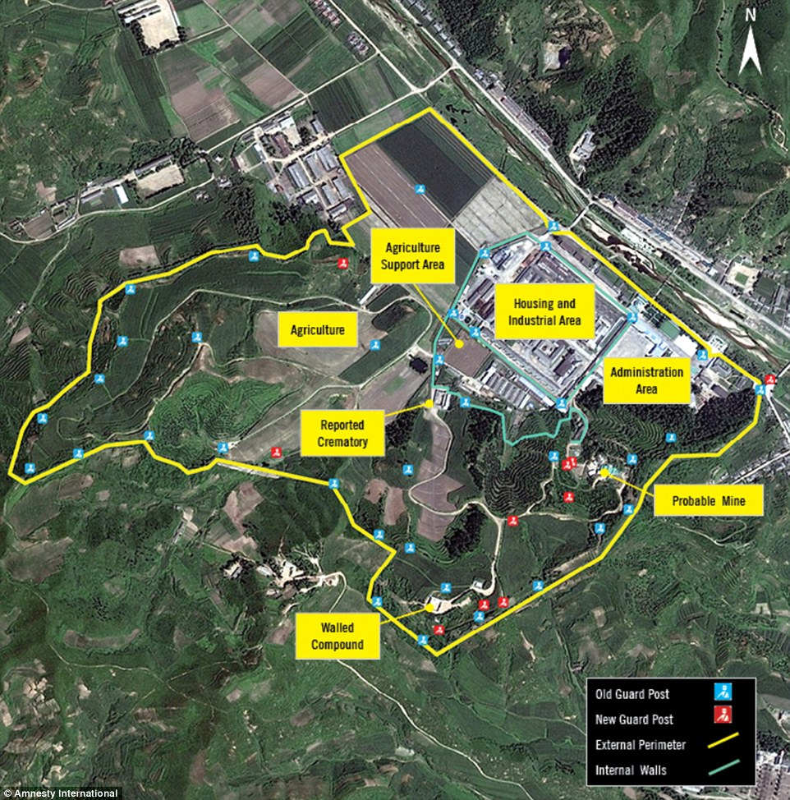
Annex 1: The satellite shows the Yodok camp (Kwan-li-so) and how the regime of North Korea is participating the torture and the violation of human right where also many people in camps didn't commit any crime but they punished them collectively
https://www.dailymail.co.uk/news/article-3965608/Satellite-images-reveal-North-Korea-expanding-brutal-prison-camps-rape-torture-executions-CHILD-MURDERS-commonplace-larger-crematoriums-needed-hide-evidence-atrocities.html

Annex 2:This picture shows the latitude line between North and south Korea in 1945
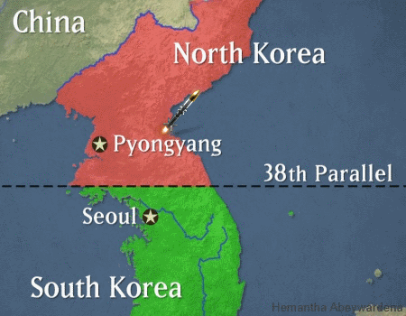
https://giphy.com/gifs/korean-jDIigAKftiXKg

Annex 3:The Treaty of shimonoseki between Japan and china ,17 April 1895
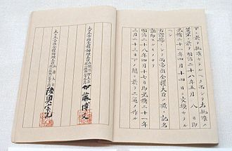
https://enacademic.com/dic.nsf/enwiki/41368

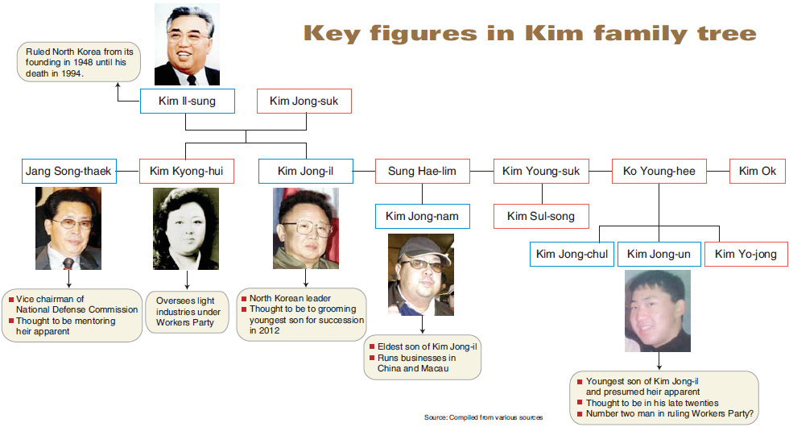
Annex 4 : The Kim Il-Sung Family
http://www.koreatimes.co.kr/www/news/nation/2014/06/120_72031.html

Annex 5: The US warship in 1968 was arrested by North Korean
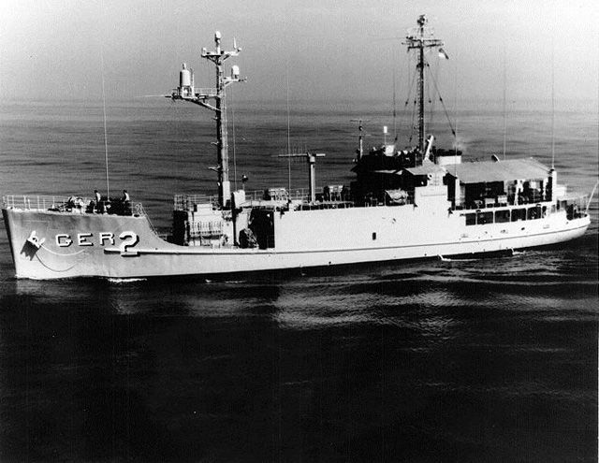

https://www.smithsonianmag.com/smart-news/time-us-nearly-nuked-north-korea-over-highjacked-spy-ship-180949514/

Annex 6:The 82 U.S sailors tortured by the North Korean regime in 1968
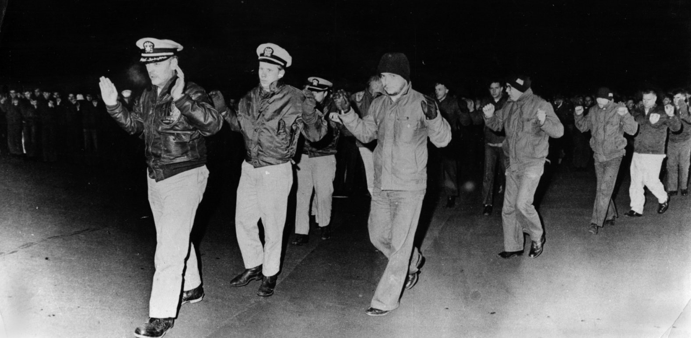
https://timeline.com/pueblo-north-korea-captured-a09d81ef2602

Annex 7:North Korea’s weapons

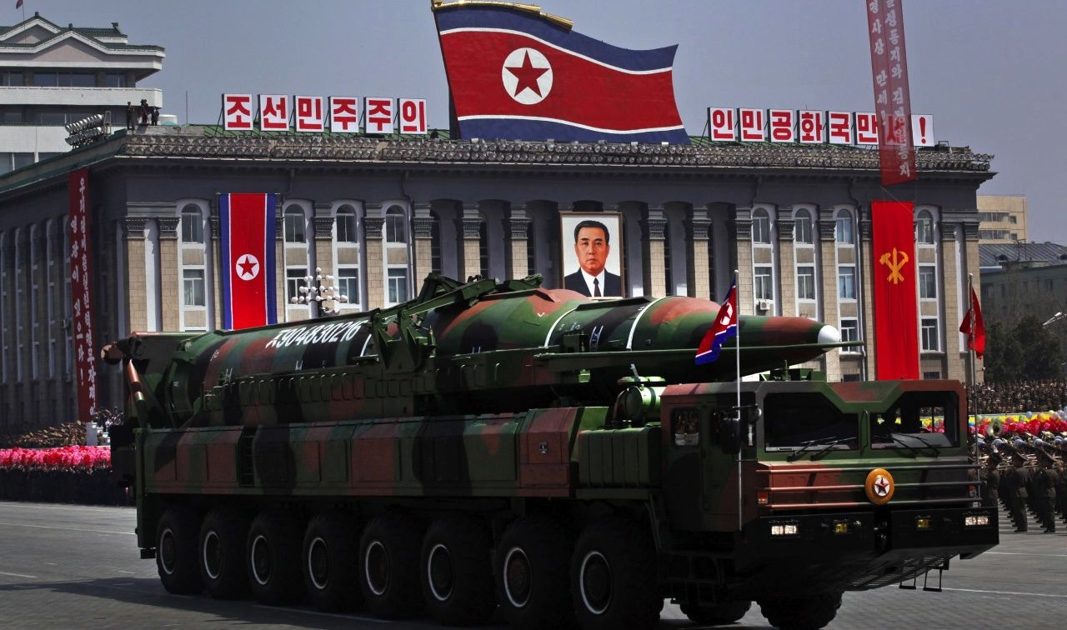
https://news.usni.org/2015/10/21/ambassador-north-korea-needs-to-give-up-nuclear-weapons-before-disarmament-negotiations-can-continue

1. See J. Stewart, The Future of the Grave Breaches Regime: Segregate, Assimilate or Abandon?, J Int Criminal Justice (2009) 7 (4):855-877.
1.https://www.ohchr.org/Documents/Publications/HR_in_armed_conflict.pdf 2.https://ihl-databases.icrc.org/applic/ihl/ihl.nsf/7c4d08d9b287a42141256739003e636b/fe20c3d903ce27e3c125641e004a92f3
1.https://treaties.un.org/Pages/ViewDetails.aspx?src=TREATY&mtdsg_no=IV-16&chapter=4&clang=_en
1.Joint Project of the British Red Cross (BRCS) and the International Committee of the Red Cross (ICRC) to update the ICRC Study on Customary International Humanitarian Law. 2.https://www.lcil.cam.ac.uk/customary-international-humanitarian-law-project. 3.https://www.france24.com/ar/20171222.
1.1.https://www.france24.com/ar/20171222 2.https://www.cfr.org/backgrounder/what-know-about-sanctions-north-korea
1.https://www.icrc.org/en/doc/resources/documents/misc/basic-rules-ihl-311288.htm 2.https://casebook.icrc.org/highlight/scope-application-law
1.https://casebook.icrc.org/highlight/scope-application-law
1.See J-M. Henckaerts and L. Doswald-Beck (eds.), Customary International Humanitarian Law, Volume I: Rules, (ICRC, Cambridge University Press, Cambridge, 2005), Rule 99: “Arbitrary deprivation of liberty is prohibited”. 2.Geneva Conventions of 12 August 1949 [hereafter “1949 Geneva Conventions”] (adopted on 12 August 1949, entered into force on 21 October 1950), Common Article 2. 3.Protocol Additional to the Geneva Conventions of 12 August 1949, and Relating to the Protection of Victims of International Armed Conflict [hereafter “AP I”] (adopted on 8 June 1977, entered into force on 7 December 1978), art. 1(4). 4 .Ibid., art. 96(3).
1.International armed conflicts https://www.coursera.org/lecture/international-humanitarian-law/international-armed-conflicts-jmXJl
1. Alawi Sattar,the forbidden land. 2.Alvis, C. (2012). Violations in the South Korean Lands. New York: IGI Global
1.Vishwanathan Arun and others, North Korea’s 2016 nuclear test:an analysis, international strategic and security program, national institute of advanced studies, banglore, india ,jan2016. 2.Tarrington Charles W, The kim Jong Il Regime In North Korea 3.S.Natisco Andrew, the great north korean famine:famune, politics,and foreign policy , Washington,DC: United states Institute of peace,2001 4.Alvis, C. (2012). Violations in the South Korean Lands. New York: IGI Global

